Mastercam Manual Code Entry

Mastercam allows users to output “manual code entry” statements to the NCI file. These statements are output to the NCI file as 1006 records. This is the Mastercam dialog box that is used for this.

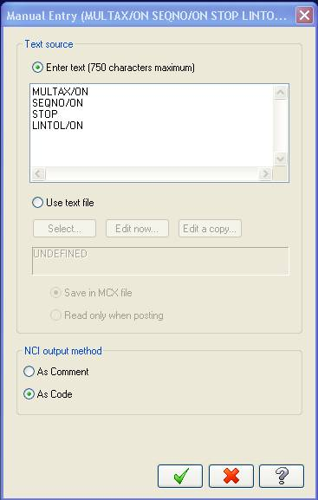

Mastercam outputs the manual code entry statements to the NCI file as 1006 records. The Austin NC translator converts the 1006 NCI record to a REMARK statement by default. In the past, users have collected REMARK statements in FIL, tested for a 1006 text within the record, and extracted the Post command from that record, then processed it. This requires users to build additional logic within FIL to process that command and can cause other problems is your FIL code reads through the CL file looking for specific records. Ideally it is best if the 1006 record would be converted directly to a Post command.
To allow this we have added a config.tbl entry to control this conversion:

MASTERCAM_REMARK_1006=ON-OFF

NCI records 1006 are generated by the "Manual Entry" dialog inside Mastercam. The user can type a post command or message as <text> and it is output as a 1006 NCI record. Our interface converts it to a REMARK 1006 <text> by default (ON). A new entry has been added to the config.tbl file to output the <text> as an ACL command (OFF), so no parsing of the REMARK text line is needed in FIL.

Example:

MASTERCAM_REMARK_1006=OFF

NCI file record:
1006
LINTOL/ON

Can be output as REMARK 1006 LINTOL/ON as before (ON) or LINTOL/ON as post processor command to the ACL file using the above option (OFF).

