Defining a User Defined Events in Siemens NX

There are times when you need a custom command output to the CLS file for the post processor so it knows to do something like switch from the upper head to the lower turret. The following three steps show how to generate a User Defined Event that will output the required post processor command and numeric values.

Step 1: Select where in the Operation Tree you want to put this function and click on the “Create Operation” button. In this dialog box choose the Operation Subtype, the location and give it a name, in this case “HEAD2”.

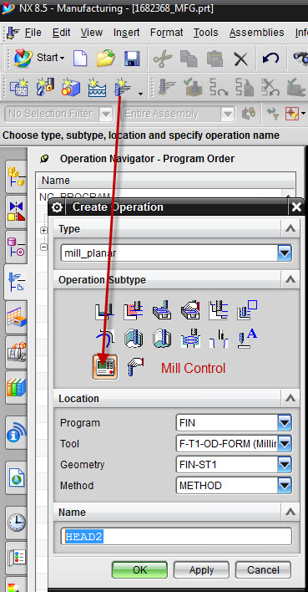
Step 2: Once the Operation is added to the Operation Tree you can select it and choose to generate a User Defined Event for this Operation under the menu item “Machine Control”.

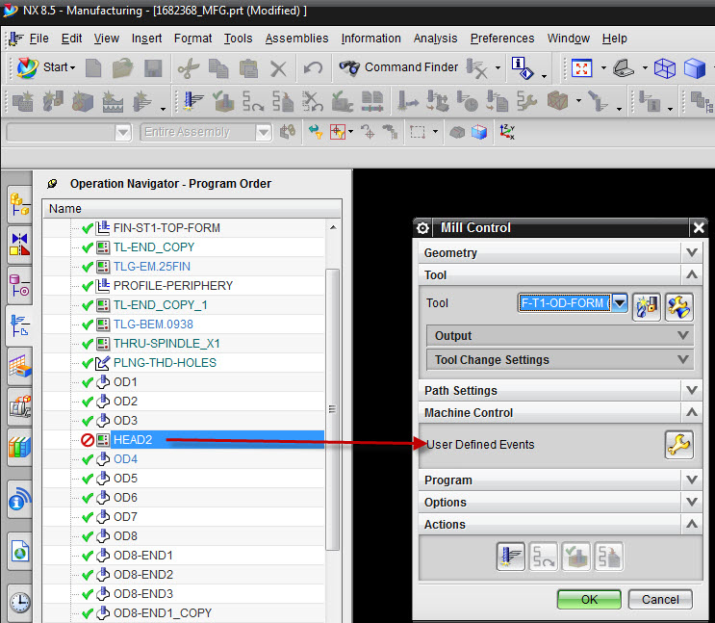

Step 3: In the User Defined Events dialog box, select “User Defined”, this will allow you to add custom commands. In this case we are adding three separate post processor commands; “HEAD/2”, SET/WAXIS,20 and SET/ZAXIS,-20. The post processor command must be in G-Post format. The command format rules are defined in the G-Post manual in chapter 4 “Command Reference”. They can be an existing post processor command of a custom command set up by the post developer.

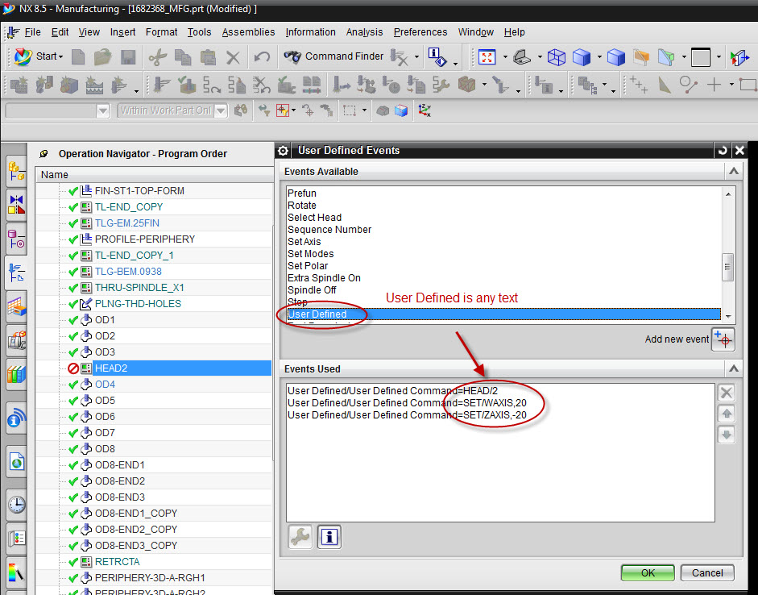

The post processor commands can also be embeded directly to the Operation but they will not be transparent in the Operation Tree.

